EDRC Use Case 1, Test Case 1, Section 7.2.4 Suction Pressure Max
Revision of EDRC doc:

11 | Updated to reflect comments from David Price | K Willshaw  30 March 2015

Test case spec release 1.0

Note that ideally we would create separate objects and identities for the Nozzles (Ports) and create associations between the Pump and its Ports for this purpose. That is the Pump would have Inlet and Outlet Ports and those ports would have the Properties for Maximum Pressure and Rated Pressure. However the Inlet and Outlet Ports have no separate existence outside the context of the pump so it seems a reasonable shortcut and there is a cost involved in implementing it this way in terms of persisting and maintaining the identities and relationships. It should be noted that in more complex cases where there multiple inlets and outlets such Short Cut templates would not be appropriate

Template Name: IndividualHasIndirectPropertyWithValue

Role Name | Role Type | Role Value
hasPossessor | dm:PossibleIndividual | EQUIPMENT Identifier
hasIndirectPropertyType | dm:ClassOfIndirectProperty | UPPER LIMIT INLET PRESSURE
valPropertyValue | dm:ExpressReal | Value of Property
hasPropertyScale | dm:Scale | MEGAPASCAL GAUGE

Comments – the valPropertyValue is not an ExpressReal in this template. It is specified as (tpl:valPropertyValue only xsd:float)

Comments – the template URI for use in the exchange file is :
http://data.posccaesar.org/tpl/IndividualHasIndirectPropertyWithValue

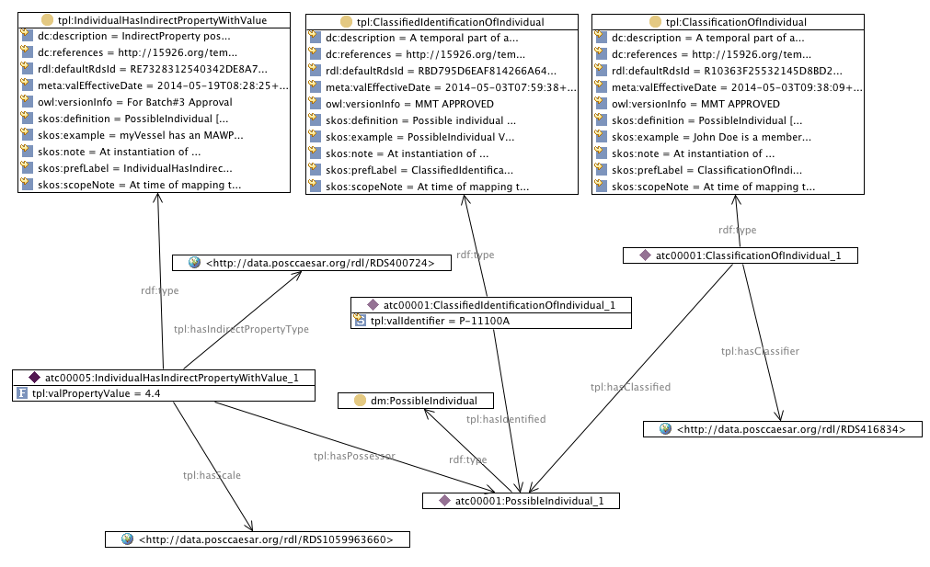

SPARQL to find Suction Pressure Max of Pump

SELECT ?PumpIdentifier ?SuctionPressureMaxMegaPascalGuage
WHERE {
?classificationofindividual tpl:hasClassified ?possibleindividual .
?classificationofindividual tpl:hasClassifier <http://data.posccaesar.org/rdl/RDS416834> .
?classificationofindividual rdf:type tpl:ClassificationOfIndividual .
?possibleindividual rdf:type dm:PossibleIndividual .
?individualhasindirectpropertywithvalue tpl:hasIndirectPropertyType <http://data.posccaesar.org/rdl/RDS400724> .
?individualhasindirectpropertywithvalue tpl:hasPossessor ?possibleindividual .
?individualhasindirectpropertywithvalue tpl:hasScale <http://data.posccaesar.org/rdl/RDS1059963660> .
?individualhasindirectpropertywithvalue rdf:type tpl:IndividualHasIndirectPropertyWithValue .
?classifiedidentificationofindividual tpl:hasIdentified ?possibleindividual .
?classifiedidentificationofindividual tpl:hasIdentificationType <http://data.posccaesar.org/rdl/RDS2100944981> .
?classifiedidentificationofindividual rdf:type ?class .
?individualhasindirectpropertywithvalue tpl:valPropertyValue ?SuctionPressureMaxMegaPascalGuage.
?classifiedidentificationofindividual tpl:valIdentifier ?PumpIdentifier .
}

